Part One: In the sentences provided below, please take three steps
- Complete the labeling table.
- Create a sentence diagram.
For these first set of problems, I have identified the sentence pattern for you. You can refer to the chart on p. 24 and look at the chapter for additional info and examples. You can also use the example trees in my Sentence Patterns Handout to help you.
In some of my tree diagrams and tables, I ask students to identify the “roles” in the sentence such as direct object (DO), adverbial (Advl), Subject Complement (Subj Comp), etc. There is no need to identify any roles for this homework assignment.
Different books number these patterns differently, so it is better to use the terminology rather than numbers. Rather than use the number, we will use words to describe the sentence pattern using one of these options:
- Copular "Be" (pattern 1 or 2. on p. 24)
  - In our class, we will combine both 1 & 2 into one group.
- Linking Verb with a Subject Complement (pattern 3 on p. 24)
- Intransitive (pattern 4 on p. 24)
- Transitive (pattern 5 on p. 24)
- Ditransitive with a Direct Object (pattern 6 on p. 24)
- Ditransitive with an Object Complement (pattern 7 on p. 24)
- The students are very tired.

- Copular Be (Adjective Phrase as a Subject Complement)

Phrase
Word | The | Students | Are | Very | Tired
Part of Speech

- My uncle was in jail.

Copular Be (Prepositional Phrase as a Subject Complement)

Phrase
Word | My | uncle | was | in | jail
Part of Speech

- The new teachers are experts in their field.

Copular “Be” (Noun Phrase as a Subject Complement)
Phrase
Word | the | new | teachers | are | experts | in | their | field
Part of Speech

- This crime smells fishy.

Linking Verb with an Adjective Phrase as a Subject Complement

Phrase
Word | This | crime | smells | fishy
Part of Speech

- Timothy became a bitter person.

Linking Verb with an Adjective Phrase as a Subject Complement

Phrase
Word | Timothy | became | a | bitter | person
Part of Speech

- Some players hit every shot.

Transitive (has a Direct Object)

Phrase
Word | Some | players | hit | every | shot
Part of Speech

- That book contains the best ideas.

Transitive (has a Direct Object)

Phrase
Word | That | book | contains | the | best | ideas
Part of Speech

Part Two
For each of the sentences below, identify the sentence pattern. If the sentence contains any of the following roles, list and identify them.
- Subject Complements or Adverbials
- Direct Objects
- Optional Adverbials

Example:
With such high stakes, no diplomats were at Camp David
- Sentence Pattern: Copular Be
  - “At Camp David” – Subject Complement
  - “With such high stakes” – Optional Adverbial

2.1: Leaders and diplomats from Egypt, Israel, and the United States were at Camp David.
2.2: The negotiations were secret.
2.3: A successful conclusion to the 1978 negotiations appeared unlikely.
2.4: The Camp David Accords were a set of agreements between former enemies
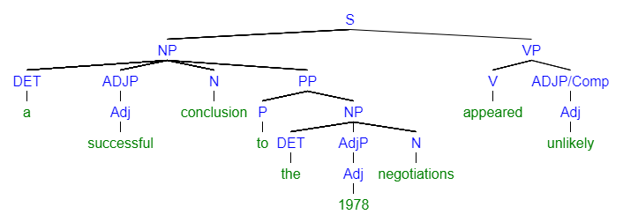

Linking Verb with a Subject Complement (pattern 3 on p. 24)
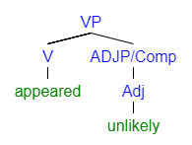
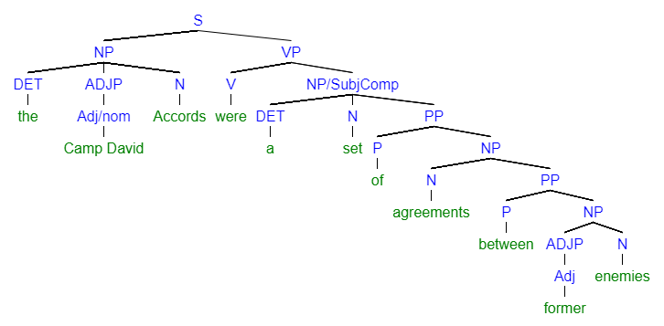

Early Lincoln pennies are very valuable today.Copular "Be" with a Subject Complement (pattern 2. on p. 24)
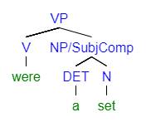

Exercise 5 – p. 26
- Part A: Please identify the sentence pattern. You can refer to the numbered chart on p. 24 and look at the chapter for additional info and examples. Just as in Exercise 4, please use words to describe the pattern rather than numbers.
- Part B: Please type out the full sentence for 2, 4, 6, and 8 with the adverbial moved to a different place in the sentence.

5.2:
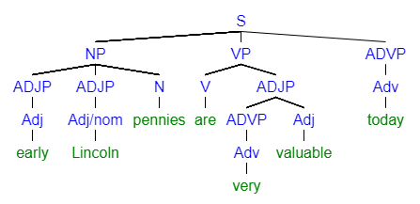

Part A: Copular "Be" with a Subject Complement (pattern 2. on p. 24)
Part B: Today, early Lincoln pennies are very valuable.
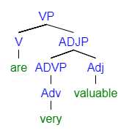
5.4: In 1943 zinc-coated steel replaced the copper in the production of pennies.
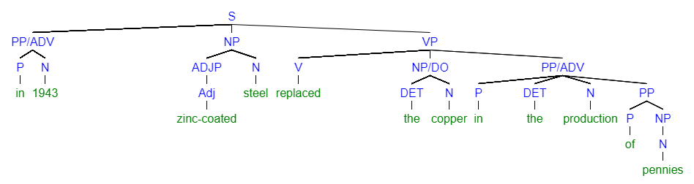

Part A: Transitive (pattern 5 on p. 24)
Part B: Zinc-coated steel replaced the copper in the production of pennies in 1943
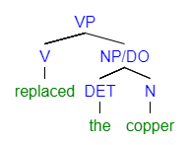
5.6: The copper blanks for those twelve pennies were still in the press hopper during the production of the zinc-coated coins.
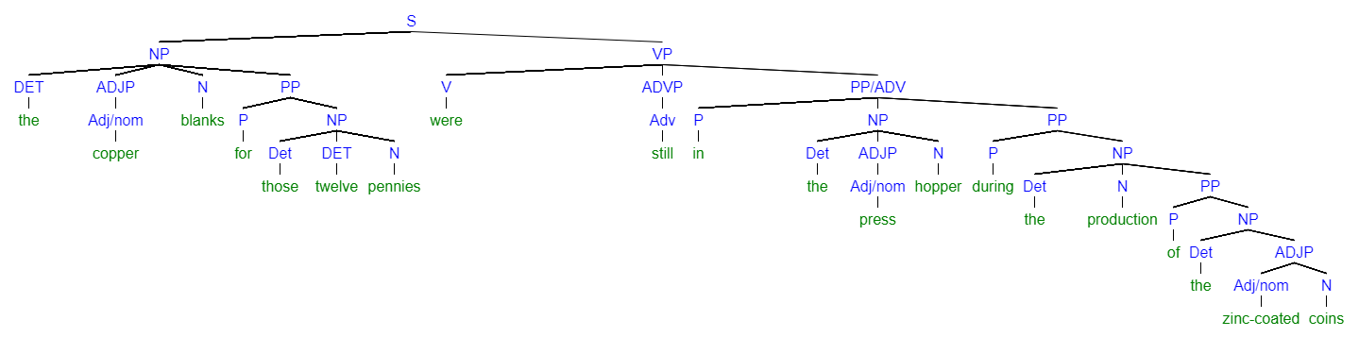

Part A: Copular "Be" with an Adverbial (pattern 1. on p. 24)
Part B: During the production of the zinc-coated coins, the copper blanks for those twelve pennies were still in the press hopper
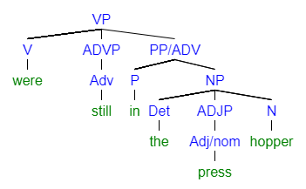
5.8: Even after 100 years, the production of the Lincoln penny continues today.
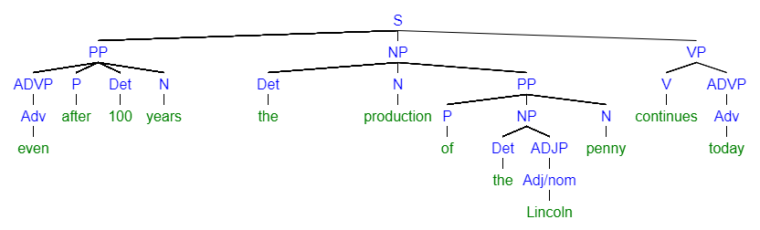

Part A: Intransitive (pattern 4 on p. 24)
Part B: The production of the Lincoln penny continues today even after 100 years.


Exercise 6 – p. 28
- Please identify the sentence pattern. Just as in Exercise 4, please use words to describe the pattern rather than numbers.

6.2: For sailors scurvy was a serious problem.
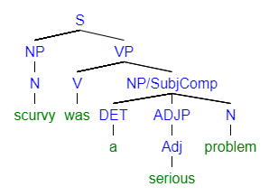

Copular “Be” with a Subject Complement (pattern 2 on p. 24)
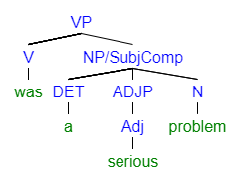

6.4: When the men consumed oranges and lemons every day, they recovered miraculously.
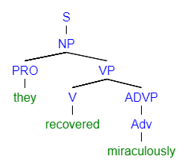

Intransitive (pattern 4 on p. 24)

6.6: Interestingly, Lind’s discovery affected the English language.
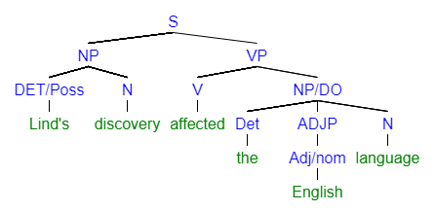

Transitive (pattern 5 on p. 24)
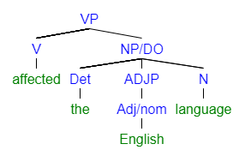
6.8: Because of that navy diet, people call British sailors limeys.
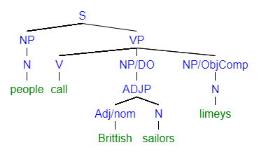

Ditransitive with an Object Complement (pattern 7 on p. 24)
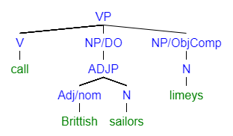

Exercise 7 – p. 29
- Explain in prose why each of the sentences is punctuated incorrectly. This kind of task can be quite hard, but do your best. Imagine you needed to explain this to a student or a fellow writer/editor in a professional setting.
7.2: After the assassination of President William McKinley, Roosevelt, took office at the age of 42.

  - The comma after Roosevelt separates the subject/noun phrase from the predicate/verb phrase. This is unnecessary and almost always incorrect.

7.4: Roosevelt told, veterans in Illinois: “a man who is good enough to shed his blood for his country is good enough to be given a square deal afterwards.”

  - This is an example of sentence pattern six, a transitive verb with an indirect object and a direct object. The indirect object is “veterans in Illinois”. The indirect object is actually the entire phrase following the colon. There is no need to place a comma between the verb (told) and the direct object (veterans in Illinois).
    - Personally, I also would not use a colon here but would opt for a comma after Illinois since the preceding section is not a complete grammatical sentence.

